Record all your data into your YILA for today. Google: PhET simulation “Forces and Motion” and open the document.

FORCES AND MOTION

You and some friends are at the park . You find some rope and decide you’d like to play a game of tug-of-war. Unfortunately, there are 5 people so you can’t have an equal amount of people on each side. One of your friends suggests that the two biggest people should be on one side, while the three smaller people should be on the other side. Do you think this is a fair way to split up teams? Why or why not?

Question: What causes objects to move or stay still?

TASK 1
- Place 2 people that are the same size the same distance away from the cart.
- Make a prediction about the movement of the cart.
- AFTER you have observed the actual movement, click on the sum of the forces box at the top right hand corner of the simulation. Record the number in the data chart.

 | Predicted Movement | Actual Movement  (none, left, right) | Sum of Forces  (0, x-left, x-right)
Same size, same placement on rope.
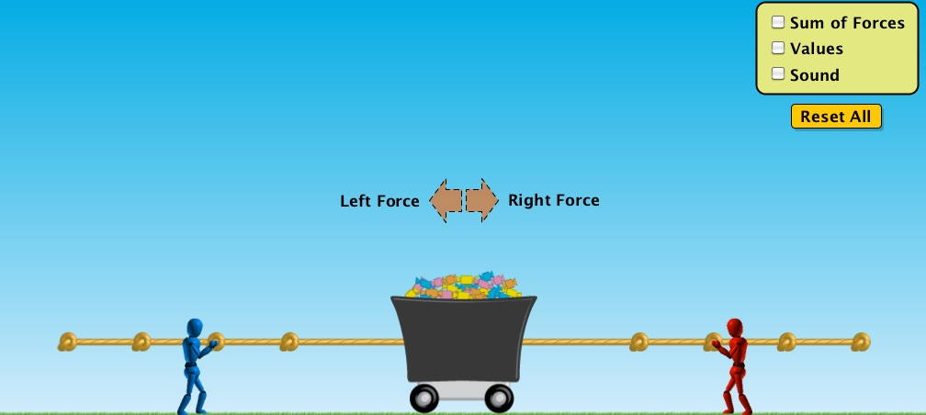

TASK 2
- Place 2 people that are the same size different distances away from the cart.
- Make a prediction about the movement of the cart.
- AFTER you have observed the actual movement, click on the sum of the forces box at the top right hand corner of the simulation. Record the number in the data chart.

 | Predicted Movement | Actual Movement  (none, left, right) | Sum of Forces  (0, x-left, x-right)
Same size, different placement on rope.
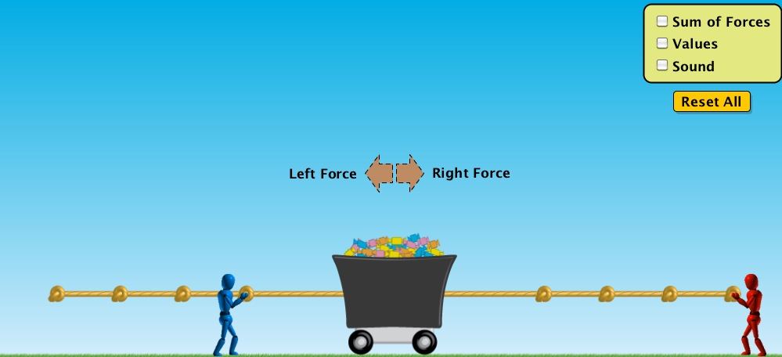

TASK 3
- Place 2 people that are different sizes the same distance away from the cart.
- Make a prediction about the movement of the cart.
- AFTER you have observed the actual movement, click on the sum of the forces box at the top right hand corner. Record the number in the data chart.

 | Predicted Movement | Actual Movement  (none, left, right) | Sum of Forces  (0, x-left, x-right)
Different size, same placement on rope.
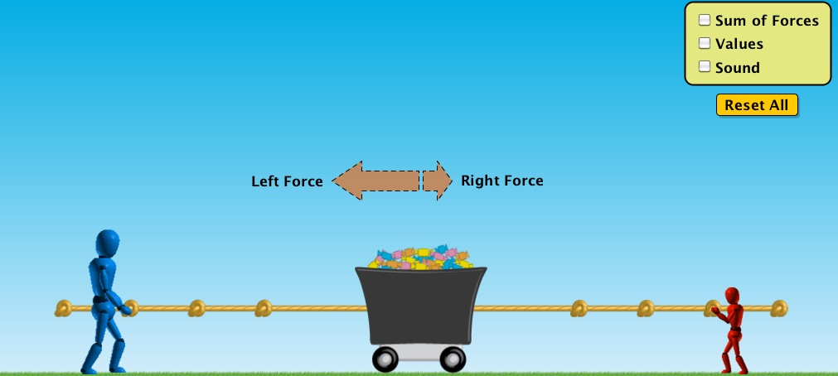

TASK 4
- Place 2 people that are the different sizes different distances away from the cart.
- Make a prediction about the movement of the cart.
- AFTER you have observed the actual movement, click on the sum of the forces box at the top right hand corner of the simulation. Record the number in the data chart.

 | Predicted Movement | Actual Movement  (none, left, right) | Sum of Forces  (0, x-left, x-right)
Different size, different placement on rope.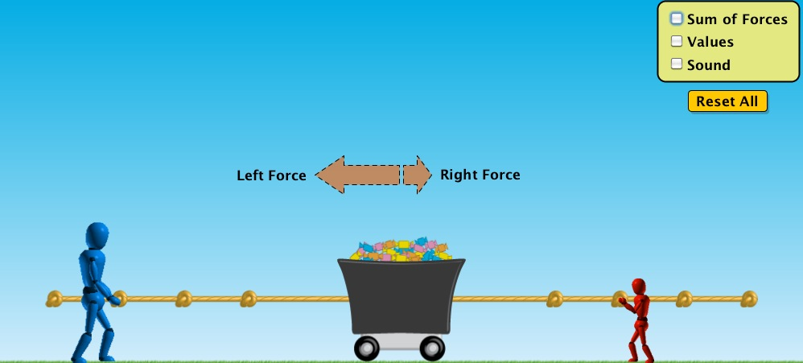

What causes objects to move or stay still?

Claim:

Evidence:

Analysis Questions/Reasoning:

- Give an example of a balanced force.

- Give an example of an unbalanced force.

- True or false? Balanced forces cause a change in motion. T/F
How do you know this?

- True or False? Unbalanced forces cause a change in motion T/F
How do you know this?

Now that you have had a chance to experiment with the simulation, go back to the question at the beginning of the investigation. What do you think would be the best way to divide up your friends for the game of tug-of-war? Be sure to explain your reasoning.

What questions/investigations do you have after using this simulation?

Devise an experiment of your own using the simulation that helps to answer your question.

